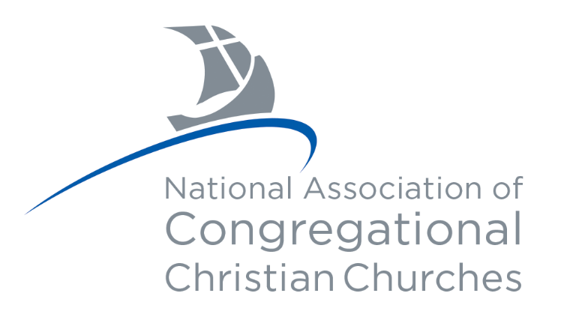



NACCC Year-Round Delegate Newsletter

→resources to share with your church←

July 2024

If you missed the 2024 Annual Meeting & Conference in Spokane, Washington, the plenary session videos are available on the event's Resources page on the website.

  
  We remind you of the importance of sharing this information with those around you who may be interested.
  By doing so, you can help us spread the word and connect with our member churches.

Educational Opportunities

Upcoming Webinars

Lay Ministry Training Program

Congregational History & Polity

Congregational Foundation for Theological Studies

Financial Resources

Congregational Investment Trust

Member Church Endowment Service

Building & Loan Program

Hurting Churches Fund

NACCC Information

Visit Our Website

NACCC E-News

NACCC Announcements

NACCC Church Listening Tour

Calendar of Events

Missions & Outreach Information

Snapshot of Missions

Missions News and Needs

One Great Hour of Sharing

Giving Opportunities

Support the NACCC

Member Church Giving Information

Year Round Delegate Information

YRD Orientation Packet

Join the YRD Facebook Group

Print this Newsletter

 |  | 

Our Contact Information
National Association of Congregational Christian Churches
8473 S. Howell Ave
PO Box 288
Oak Creek, WI 53154
(414) 764-1620
http://www.naccc.org

